

**Benefits   
Management   
Toolkit**

**V1.1 Budget 2024-25**   
January 2024

**Digital Transformation Agency**



© Commonwealth of Australia (Digital Transformation Agency) 2019

With the exception of the Commonwealth Coat of Arms and where otherwise noted, this product is provided under a Creative Commons Attribution 4.0 International Licence. (<http://creativecommons.org/licenses/by/4.0/legalcode>)

The Digital Transformation Agency has tried to make the information in this product as accurate as possible. However,   
it does not guarantee that the information is totally accurate or complete. Therefore, you should not solely rely on this information when making a commercial decision.

Digital Transformation Agency is committed to providing web accessible content wherever possible. If you are having difficulties with accessing this document, please email [communications@dta.gov.au](mailto:communications@dta.gov.au).

Version: 1801

**Contents**

1. Introduction 3

1.1 Purpose 3

1.2 Background 3

1.3 How to Use the Toolkit 4

1.4 Reference Information 4

1.5 Definitions 5

2. What is a Benefit? 6

2.1 Purpose 6

2.2 What is a ‘Benefit’ in Benefits Management? 6

2.3 When are Benefits Identified? 7

2.4 How are Benefits Identified? 7

2.5 Why Must Benefits be Measurable? 8

2.6 What Benefit Measurements are Required? 8

2.7 Who is Responsible for Benefits Management? 9

2.8 Misidentification of Benefits 10

3. Preparing Benefits Management Documentation 14

3.1 Benefit Mapping 14

3.2 Benefit Profiles 16

3.3 Benefits Realisation Planning (BRP) 19

3.4 Benefits Governance 20

4. Frequently Asked Questions 25

Appendix 26

A. Examples of Benefit Maps 26

**1. Introduction**

**The DTA has created a Benefits Management Toolkit (Toolkit) to assist agencies to meet Digital Capability Assessment Process (DCAP) requirements for investments coming forward to Budget in 2024-25.**

## **1.1 Purpose**

The DTA has developed the Toolkit to supplement the guidance contained in the Benefits Management Policy (BMP). The Toolkit provides agencies with guidance to complete the four benefits management assessment criteria in the DCAP. Importantly, the Toolkit is an iterative product which will be regularly updated in response to agency feedback and lessons learned in the Budget 2024-25 process.

## **1.2 Background**

The Australian Government has endorsed the application of the BMP for digital and ICT investments coming forward for Cabinet consideration under the digital and ICT Investment Oversight Framework (IOF).

The BMP describes how investment benefits must be managed across the Australian Government digital and ICT portfolio and supports agencies to successfully articulate, manage and realise these benefits. The BMP is a structured approach designed to provide program sponsors and Government with confidence that digital and ICT-enabled investments will achieve their intended objectives.

Investment alignment, including alignment with better practice benefits management principles, is assessed during the contestability state of the Investment Oversight Framework (IOF) with investments required to meet specific requirements in the DCAP. The IOF applies to all digital and ICT-enabled investments irrespective of size, scale, and complexity (*Figure 1*).

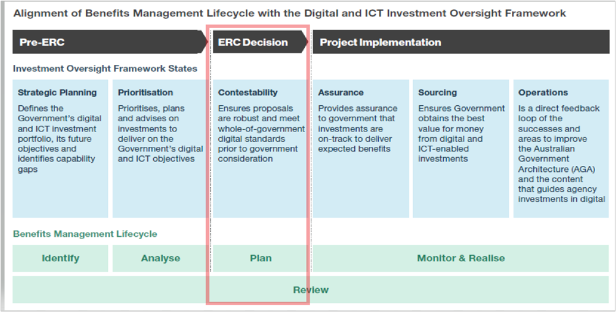

**Figure 1:**   
Benefits   
Management   
in the IOF

## **1.3 How to Use the Toolkit**

The Toolkit contains information, advice and guidance that will be updated regularly to reflect feedback and lessons learned during the Budget 2024-25 assessment period.

A benefit profile template is available for download on the [AGA website](https://architecture.digital.gov.au/benefits-management-guides-and-tools) or readers may navigate directly to the following document sections, each of which includes links to the relevant template, where available.  
  
 **The Toolkit contains the following sections:**

**Section 1** introduces the Toolkit and provides links to key information sources, including definitions.

**Section 2** provides guidance around articulating benefits, including common errors when identifying benefits.

**Section 3** provides advice, guidance, and options for documenting and managing investment benefits, in accordance with BMP principles, using key steps in the benefit management lifecycle.

**Section** **4** provides links to frequently asked questions about the BMP and the DCAP.

## **1.4 Reference Information**

Important BMP information can be found at the following links:

* [Benefits Management Policy](https://www.dta.gov.au/sites/default/files/2023-08/Benefits%20Management%20Policy%20V03%20DTA%2024072023_0.pdf)
* [Application of the Benefits Management Policy](https://architecture.digital.gov.au/benefits-management-guides-and-tools)
* [Digital Capability Assessment Process (DCAP)](https://www.dta.gov.au/help-and-advice/digital-capability-assessment-process-dcap)
* [Australian Government Architecture (AGA) website](https://architecture.digital.gov.au/benefits-management-guides-and-tools)

## **1.5 Definitions**

A comprehensive list of definitions can be found in the Glossary section of the [BMP](https://www.dta.gov.au/benefits-management-policy). The following definitions provide additional context relevant to the assessment of the BMP in the DCAP.

| Item | Term | Definition / Explanation |
| --- | --- | --- |
| 1 | **Benefit** | The measurable improvement from change, which is perceived as positive by one or more stakeholders, and which contributes to organisational (including strategic) objectives. |
| 2 | **Benefits Management** | The identification, quantification, analysis, planning, tracking, realisation, and optimisation of benefits. |
| 3 | **Benefits Management  Policy (BMP)** | The BMP defines how benefits must be managed across the Australian Government digital and ICT portfolio. The policy supports agencies to deliver digital and ICT outcomes by detailing investment oversight requirements and providing guidance on benefits management.  The BMP document includes Policy, Standard, Guidance and Process components. Through the application of these components, agencies can ensure that digital and ICT-enabled investments successfully realise investment objectives. |
| 4 | **Policy  Statements** | The policy statements consist of eight best practice principles for benefits management. |
| 5 | **Digital Capability Assessment Process (DCAP)** | The DCAP is the process the DTA applies to contest digital investments coming forward in the Budget process to ensure they are aligned with Cabinet-agreed digital policies and standards. The DCAP underpins the Contestability state of the Digital and ICT Investment Oversight Framework. The BMP is one of the policies in the DCAP. |
| 6 | **Benefit Map** | A pictorial representation of the business changes on which benefits realisation depends and how these benefits contribute towards strategic objectives. |
| 7 | **Benefit Measure** | One or more agreed measurable performance indicators used to demonstrate the achievement of a benefit. |
| 8 | **Benefit Profile** | The document used to record and reach agreement (with the Benefit Owner) on the key details about a benefit (or disbenefit) including categorisation, measures, calculation, baseline, target, and any dependencies. |
| 9 | **Benefits  Realisation  Plan** | The plan that provides a consolidated view of the benefits forecast by category and which represents the baseline against which benefits realisation can be monitored and evaluated. It should also capture governance arrangements, risks to realisation, and assumptions. |

**2. What is a Benefit?**

## **2.1 Purpose**

The purpose of this section is to explain what is, and what is not, a benefit for benefits management purposes.

This section will be useful to those new to benefits management or those who need guidance in articulating benefits.

## **2.2 What is a ‘Benefit’ in Benefits Management?**

In everyday conversation, a ‘benefit’ is typically described as ‘an advantage that something gives you’ or a ‘helpful and useful effect that something has’.

However, in the context of benefits management, this is **NOT** what ‘benefit’ means.

In benefits management, at the most basic level, a ‘benefit’ is the specific, measurable improvement that will be delivered as a result of business change.

Benefits management, by extension, is the process of tracking and estimating the value to be delivered by performing a project and then measuring that value at various intervals before, during and after a project has been completed.

|  |
| --- |
| **DTA TIP:** In business cases and benefits management artefacts, use short, concise benefit descriptions that clearly demonstrate the impact of the benefit. Examples of clear and concise benefits are:   * **Reduce** incidence of provider fraud in disability claims. * **Increase** network security to reduce incidence of cyber-attacks. * **Increase** efficiency of payment processes for compensation claimants. |

## **2.3 When are Benefits Identified?**

Investment benefits are identified early in the investment planning process before funding is requested and **before** **a project has been initiated**.

Articulation of benefits in the early investment planning stages does not require knowledge of the specific digital and ICT solution but rather an understanding of what value a solution is expected to provide an organisation (the benefits).

For example, if an organisation has data scattered across its organisation in manual databases, the benefits of a technology-based, data solution would centre on better, accurate, and more reliable access to organisational data. The actual technology solution may bring many other benefits but, at a high level, the solution needs to deliver this specific value (benefit) to the organisation.

|  |
| --- |
| **DTA TIP:** An investment may realise many benefits. However, the DTA only requires top-level benefits. These are the highest priority benefits that capture the intent of the investment and will provide the clearest evidence that an investment has achieved its stated aims. The DTA expects the following number of benefits to be detailed in benefits management artefacts:   * Tier 1 proposals - 1 to 5 top-level benefits. * Tier 2 proposals - 1 to 3 top-level benefits. * Tier 3 proposals - 1 to 2 top-level benefits. |

Establishing benefits early in the investment planning process is crucial to establishing the scope of a project by providing a clear, high-level understanding of what a project aims to achieve and how success will be measured.

## **2.4 How are Benefits Identified?**

Identification of benefits typically takes place in workshops which are usually convened early in the investment planning process and before a solution is decided. The outcome of this process is a benefits map or an investment logic map which provides a clear visual representation of the investment’s rationale, the problems it aims to address and the benefits it expects to deliver.

|  |
| --- |
| **DTA TIP:** A benefits map is a foundational benefits management artefact upon which all other benefits management artefacts are based. Benefits maps are evidence that sufficient analysis has been undertaken to understand the business problem and the potential benefits to be reaped from fixing the problem.  This is why early-stage investments, such as new policy proposals (NPPs), are expected to provide complete benefit maps. Business case documentation, benefit profiles and Benefits Realisation Plans (BRPs) are also expected to be consistent with benefit maps. |

Benefit mapping is explained in more detail in section 3.1 of this document, with several examples documented in Appendix A.

## **2.5 Why Must Benefits be Measurable?**

Benefits must be measurable because:

* they justify the investment in a project
* they provide a clear, objective way to assess the impact of a change initiative
* they make organisations accountable for overstating what can be achieved from a proposed solution
* they provide a clear comparison of performance before and after a solution is delivered
* they ensure accountability and transparency about whether a benefit has been realised or not
* tracking the value of benefits over time helps an agency understand if a project was (or is still) valuable and worth continuing, given any changes that happened since commencement.

## **2.6 What Benefit Measurements are Required?**

To be measurable, a benefit must specify one or more methods of measurement (measures) that clearly show the improvement generated by new business outcomes resulting from delivery of a project’s products and services.

Specific requirements for measuring benefits are detailed in the [benefit profile template](https://architecture.digital.gov.au/benefits-management-guides-and-tools) provided by the DTA and include:

* a baseline: the starting point against which future progress can be measured
* a target: the end goal that shows that an investment has achieved what was predicted
* a measure: the metric that will be used to track and assess the progress and success of a benefit.

**Examples of benefits and potential measures are provided below.**

| **Benefit** | **Measures** |
| --- | --- |
| Improved service delivery | Customer response times, customer satisfaction scores, customer complaints. |
| Cost savings | Time saved, error rates, staff counts, costs of doing business. | |
| Enhanced security | Number of security incidents or cyber-attacks, incident response times, system down time. | |
| Improved decision  making (data project) | Tracking the number of decisions made using the data provided by the project, or by assessing the outcomes of those decisions. | |
| Fraud reduction | Reduction in fraud rate, dollars lost, number of incidences, comparisons against industry standard. | |

|  |
| --- |
| **DTA TIP**: Any number of benefits are likely to ensue from an investment. However, unless these benefits can be reliably measured before, during and after project completion, these will generally not be considered benefits for benefits management purposes. |

Benefit measures are detailed in benefit profile templates, which are discussed in more detail in section 3.2.

## **2.7 Who is Responsible for Benefits Management?**

While benefits management is a collaborative effort across time and across business and project teams, it is benefit owners who are ultimately responsible for realising the benefits of a change initiative.

**Note: The benefit owner is a business role**, **not a project role.**

The benefit owner has responsibility for not overstating the benefits to be achieved from a particular solution, for ensuring benefits are aligned with strategic organisational objectives, and for realising the promised value to the business after the project has been transitioned to Business As Usual (BAU) operations.

It is therefore crucial that relevant business areas are involved in early investment planning and mapping prior to solution funding and project initiation.

|  |
| --- |
| **DTA TIP:** Investments that cannot show business ownership of benefits, including business involvement in the investment planning process, will not meet the requirements of the DTA’s benefits management DCAP.  Business areas must be active participants in investment mapping, agree the measures in benefit profiles, and ensure benefits realisation is actively accounted for in organisational and project governance structures. |

Benefit governance is explained in more detail in section 3.4 of this document and sets out key benefit management roles and responsibilities.

## **2.8 Misidentification of Benefits**

### What are benefits, project outputs, enabling changes, business changes, business outcomes?

A common problem encountered by the DTA when assessing benefits management documentation is that project outputs (also called project deliverables) and the associated organisational changes required to transition a project’s products and services into business use (the ‘enabling’ and ‘business’ changes) are often misidentified as benefits.

In benefits management, ‘*project output*‘, ‘*enabling change*’, ‘*business change*’, and ‘*business outcome*’ are terms initially used in benefit mapping. The benefits map visually charts the path to benefit realisation, typically depicting how the business changes, which are necessary to implement project outputs, result in business outcomes that generate benefits. Mapping each of these paths makes it far less likely that benefits will be miscategorised.

Benefit mapping also makes clear the responsibilities of various business and project teams in the benefit realisation process; namely:

* project outputs are delivered by project management teams
* business and enabling changes are managed by change management teams
* benefits are realised by the business area with support from business change managers.

The following section explains these terms in more detail.

### What are Project Outputs and how are they misidentified as benefits?

Project outputs are the tangible deliverables (products, services) produced by a project and delivered by project management teams. Examples include:

* Customer relationship management systems
* Grants hubs
* Databases
* Cyber security infrastructure.

The project management team may well consider successful delivery of project outputs to be major benefits of a project. Project outputs do have value in and of themselves and the everyday use of ‘benefit’ is not incorrect in this context.

However, in benefits management, a benefit is defined as the value to the business that occurs once the project’s products and services have been transitioned into BAU and the resulting outcomes deliver their intended results.

### What are Enabling and Business Changes and how are they misidentified as benefits?

Transitioning a project’s products and services into BAU requires organisational changes. These changes, which are referred to as ‘*enabling changes*’ and ‘*business changes’,* are typically managed by change management teams working with project and business teams. These are also misidentified as benefits.

Specifically:

* *Enabling Changes* are typically once-off activities or deliverables that support the delivery of a larger business change. They are designed to help an organisation adapt to new circumstances and take advantage of new opportunities. Examples of enabling changes may be:
  + the creation of employee training manuals for a new IT system
  + the transfer of existing data into a new database.

Both examples are once-off changes that are necessary to ensure the products produced by a project can be used by business areas.

* *Business changes* are the direct result of enabling changes. They are the new strategies, operating models, people, processes and structures adopted by an organisation to transition project outputs to business outcomes. Examples of business changes may be:
  + organisational restructures made necessary by changed capability
  + new business processes required to facilitate the introduction of a new service.

Investment benefits are realised ONLY IF the enabling or business changes produce business outcomes that result in both measurable improvement AND are perceived as an advantage by one of more stakeholders.

### Benefits terminology in practice

The below simple example demonstrates the use of the terminology discussed in this section.

**Scenario**: An agency proposes an investment to reduce the incidence of provider fraud in claims management systems. Currently, providers can establish an account with limited identity verification and logon procedures are not secure. An unknown number of providers are assumed to be illegitimate business entities who are falsifying claims. In this case:

* The *project output*: a new claims management system.
* An *enabling change*: providers will need to authenticate their identity in MyGov before they can create a provider login in the new claims system.
* A *business change:* all providers must enter a password and a phone verification code each time they log into the new claims management system.
* The *business outcome:* only authorised providers can lodge claims for payment.
* The *benefit* of the investment: a reduction in the incidence of provider fraud
* Likely benefit *measures* may include tracking the incidence (percentage, number) of existing, active providers who fail to re-establish an account in the new claims management system (where this is not due to natural attrition or system issues), and the reduction in complaints against providers perceived where these complaints relate to specific fraudulent behaviours.

The DTA has compiled a benefits management [**case study**](https://architecture.digital.gov.au/benefits-management-guides-and-tools) which takes a business problem and steps through the various benefits management requirements. The case study has examples of benefits management artefacts and may provide additional assistance when completing the Digital Capability Assessment Process (DCAP).

### How can benefit miscategorisation be fixed?

Benefit miscategorisation frequently occurs when early investment planning and benefit mapping has not occurred prior to a funding decision AND the benefits of a solution have not been clearly articulated before initiating a project or programme of work.

In the event that investment planning teams have proceeded to solution stage, received funding, or engaged a project team without articulating investment benefits, they must, in conjunction with the relevant business areas (and the project teams if they have already been engaged), reverse-engineer an investment logic or benefits map to identify the benefits likely to accrue to the organisation from its investment in change.

Both business benefit owners and project teams (if they have been engaged) must agree that benefits can be realised, the timeframes for realisation, and how benefits will be measured. Project teams must re-evaluate the scope of the project to ensure that the project delivers a solution that satisfies benefit forecasts.

|  |
| --- |
| **DTA TIP:** To reverse-engineer an investment map, it may be easier to produce two separate benefit maps. The first map could simply detail the business problem, outcomes, the benefits, and the strategic objectives satisfied by the benefits. This makes the investment logic clear.  The second map could detail, at the very least, project outputs, business changes, the benefits articulated in the first map, and benefit measures. Benefit articulation may be assisted by including business outcomes. This approach is acceptable to the DTA, and mapping examples are provided in Appendix A. |

**3. Preparing Benefits Management Documentation**

This section provides guidance on preparing benefits management artefacts.

Examples are available throughout this section and in the [benefits management case study](https://architecture.digital.gov.au/benefits-management-guides-and-tools). Alternately, navigate to the relevant section below.

|  |  |  |
| --- | --- | --- |
| Subsection | Benefit Lifecycle Phase | Guidance Topic |
| 3.1 | **Identify** | **Benefit Maps** |
| 3.2 | **Analyse** | **Benefit Profiles** |
| 3.3 | **Plan** | **Benefit Realisation Planning** |
| 3.4 | **Review** | **Benefit Governance** |

## **3.1 Benefit Mapping**

### What is benefit mapping?

Benefit mapping is a technique used to identify and map the key benefits and enabling changes on which benefits realisation depends to an organisation’s strategic objectives. Benefit mapping is a technique used to comply with the DCAP criterion 8.1.

### What steps are typically required to produce a benefits map? **Step 1 Workshopping the Benefits**

Benefits mapping can be undertaken in a series of workshops where all relevant stakeholders share and contest ideas. Stakeholders should include and are not limited to:

* Senior Responsible Officer (SRO)
* Business change managers
* Benefits managers
* Programme / project managers
* Business benefit owners.

**Step 2 Problem Identification**

A clear understanding of the problem or opportunity helps determine the desired benefits which, in turn, are used to shape technical and non-technical solutions.

**Step 3 Benefit Mapping**

Once the key benefits are outlined, benefits mapping is used to map objectives, benefits and the business changes required to achieve the benefits. An example of benefits mapping is shown in *Figure 2*.

*Appendix A* contains examples of different mapping techniques that are easily adapted and may be more suitable to earlier or late-stage investments.  
  
*Figure 2: Benefit Mapping*

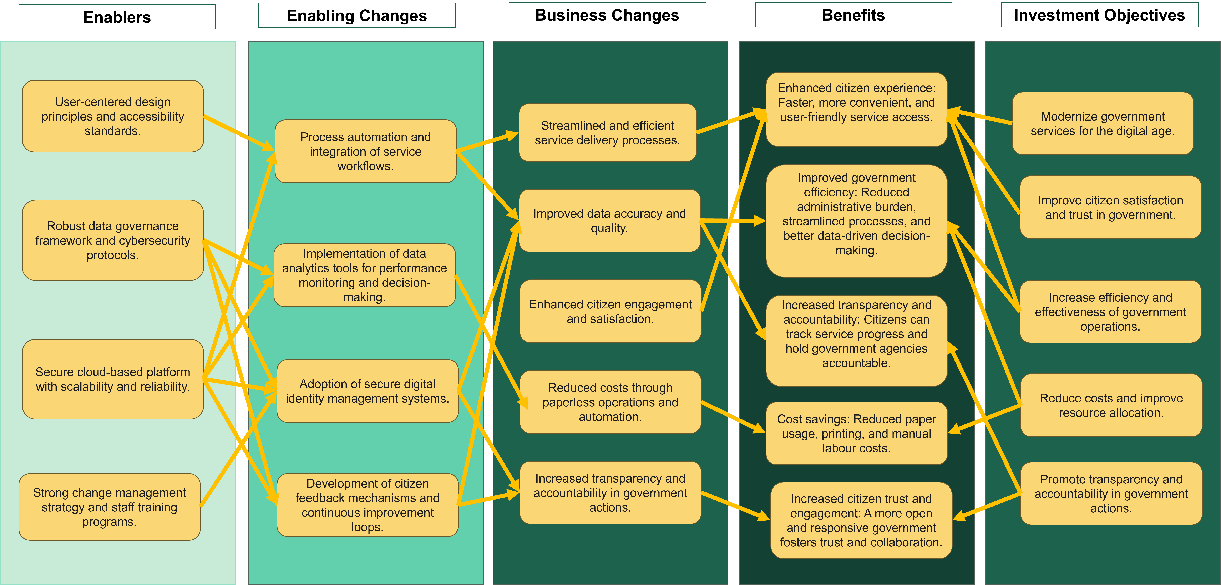

**Step 4 Iterate**

Benefit mapping is an iterative process which should be revisited multiple times during the investment. This will ensure that unintended consequences (disbenefits) are accurately factored into the investment planning process and that the investment remains on track to realise intended benefits.

### 

### Which mapping technique should I use to comply with DCAP criterion 8.1?

There are a number of mapping techniques that can be used, each with their own strengths and weaknesses. The DTA does not prescribe a particular mapping technique as the technique used will be influenced by organisational context, and investment size, stage and complexity.

A number of different mapping techniques are suggested in *Appendix A* and these can be adapted to suit organisational needs and investment stages. For example, examples 1, 2 and 3 may be more suitable for early-stage investments where the digital and ICT-enabled solution has not yet been decided. Alternately, examples 4 and 5 may be more suitable for an investment that has undertaken preliminary solution definition to understand what high-level project outputs will be delivered.

Whatever mapping technique is selected, benefits should be derived from the problem context with solutions subsequently derived from the benefits.

## **3.2 Benefit Profiles**

Investments that are subject to the IOF require a benefit profile for each identified investment benefit. Completed benefit profiles are needed to comply with the DCAP criterion 8.2.

### What is a benefit profile?

A benefit profile describes an investment benefit in more detail and specifies how progress towards realisation of that benefit will be measured and reported.

Benefits quantification workshops, also undertaken with key subject matter experts, build on investment mapping outcomes to determine the scale of change required, confirm the current level of performance (the baseline) and determine the appropriate ways to measure (benefit measures) how the proposed benefits will be realised (benefit targets).

NOTE: Benefits, as defined in the context of the discipline of benefits management, must be measurable. If benefits are not expressed in measurable terms, it is not possible to baseline performance or effectively demonstrate improvement. *Benefit profiles that do not clearly and concisely articulate benefits or define measures will not satisfy criterion 8.2 in the DCAP.*

### Are benefit profiles required for early-stage investments, e.g., NPPs?

Yes, benefit profiles are required for all investments, including early-stage investments. Benefit profiles consolidate and build on information from the stakeholder workshops and investment mapping described in ***2.1 Benefit Mapping*** above.

Early-stage investments are expected to have undertaken preliminary stakeholder or investment mapping workshops to identify the problem (or opportunity), the scope of change required, and the benefits that will be made possible by change.

It is not expected that very early-stage investments are able to provide all benefit measures, but it is expected that the necessary workshops, mapping and quantification has occurred to inform an investment approach and draft benefit profiles. In this case, benefit profiles are expected to be fully finalised in later budget comebacks.

### What will the DTA do with the benefit profiles it collects?

The DTA will record the information received in benefit profiles in a centralised whole-of-government *Portfolio Benefit Register* (PBR). This information will be used to track and report benefits realisation progress across the Australian Government digital and ICT portfolio for the purpose of ensuring investments are delivering their intended benefits.

Agencies will also be required to provide regular updates on benefits realisation progress, both during and after implementation and these will be updated in the PBR.

### Where can I download the DTA Benefit Profile Template?

The benefit profile template is available for download on the [AGA website](https://architecture.digital.gov.au/benefits-management-guides-and-tools) and contains a guidance section to assist agencies complete the template to the standard required in the DCAP. While agencies may use their own benefit profile templates, these must include all information requested in the DTA benefit profile template, at a minimum.

Figure 2: DTA Benefit Profile Template Excerpt

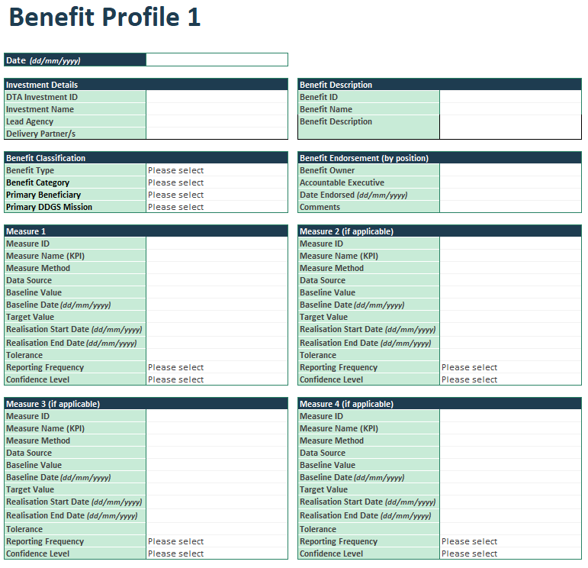

## **3.3 Benefits Realisation Planning (BRP)**

### What is a BRP?

A BRP outlines how the benefits of an investment will be achieved and measured. Its purpose is to ensure an investment delivers its intended value.

A BRP, or other suitable benefits management documentation, is a requirement for DCAP criterion 8.4. For larger proposals, this information will typically be captured in a dedicated BRP, which is the document preferred for the DCAP. Smaller proposals will generally present this information as part of other investment documentation (e.g., the New Policy Proposal (NPP) documentation).

The BRP describes the context, structure, and approach to the realisation of planned benefits and is typically developed alongside the business case (at least to initial draft level) to ensure there is a clear plan for the realisation of benefits outlined in the business case.

The BRP documents the timeframe, tools, resources, and processes by which the benefits are prioritised and achieved for each identified stakeholder group. It also defines benefit management roles and responsibilities, benefit performance measures, and governance arrangements, all in the context of relevant assumptions, constraints, and dependencies inherent in the adopted approach to benefit realisation.

To support successful benefit realisation, benefit-related activity commences early in the investment planning process and influences the approach taken in the delivery lifecycle. Benefit realisation also continues past completion of the delivery lifecycle, “Go Live” and BAU handover.

A typical BRP, whether a stand-alone document or a section in a NPP, will address the following content in a way that suits both the size, complexity, and nature of the project or program for which the BRP is written.

### BRP- Suggested Content

**Introduction**

* Purpose & Scope of the Plan
* Background to the Initiative
* Strategic and wider government objectives

**Benefits**

* Methodology and Approach
* Definition of Terms
* Benefit Identification
* Benefit Maps

**Benefit Profiles**

* Description of Benefits and Owners (including disbenefits)
* Benefits Measures and Metrics
* Assumptions and Risks
* Timeframes and schedules for benefits realisation and reporting

**Governance**

* Roles and Responsibilities
* Governance and Accountability (including handover activities and post-implementation governance arrangements)
* Reporting and Documentation mechanisms

**Benefit Realisation**

* Benefits Realisation Summary (benefits, timeframes, business and enabling changes, baselines, targets, realisation dates)
* Timeframes
* Transition Management (pre- and post-transition)
* Schedules for benefits realisation and reporting

**Benefits Evaluation & Review**

* Pre- and post-implementation reviews
* Lessons Learned

### Is a BRP a requirement for all investments in the DCAP?

A finalised BRP is a requirement for all investments coming forward to budget where full or final funding is sought. Larger investments that can provide early-stage, initial drafts that incorporate a high-level overview of the content described above will be viewed favourably. Specific inclusions are summarised in criterion 8.4 in the DCAP and a sample BRP is available in this [case study](https://architecture.digital.gov.au/benefits-management-guides-and-tools).

## **3.4 Benefits Governance**

### Why is benefits governance important?

Ownership and accountability are critical to effective governance and to ensure transparent reporting of performance. This requires clearly defined and documented roles, responsibilities and accountabilities to ensure benefits are optimised during delivery and realised after delivery.

### Who is responsible for benefits governance?

While the SRO is accountable for an investment meeting its objectives and optimising benefits realisation, responsibility for benefits extends well beyond the life of any initiative and requires clearly defined **benefits ownership at the business level**, including for all enabling and business changes required to realise the benefits.

Integration of benefits management into the wider organisational governance framework ensures visibility of benefits realisation across the change portfolio, while integration into portfolio, programme and project governance frameworks ensures regular benefits tracking, reporting and management of benefits at the delivery level.

### What must benefits governance documentation include?

Governance documentation must include key roles and responsibilities, as summarised in *Figure 3* below.

Figure 3: Benefits Governance - key roles and responsibilities

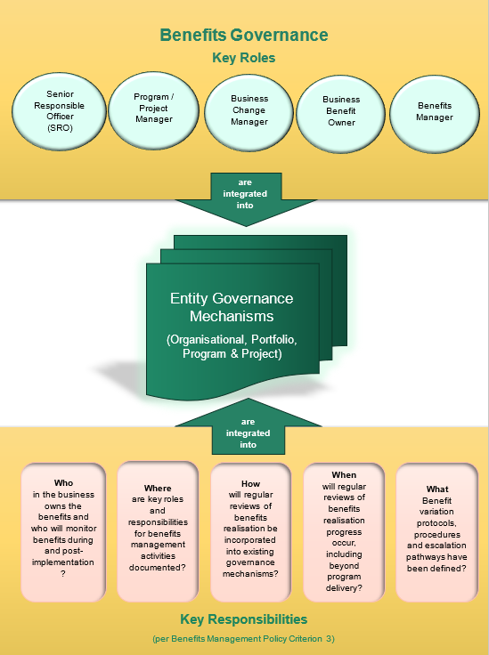

### What benefits management governance documentation must be submitted with a DCAP?

As greater levels of government scrutiny are applied to investments that take a staged funding approach, governance requirements for these investments are relaxed in the DCAP in earlier investment stages. The below requirements are a general guide noting that all governance requirements will be finalised in consultation with a DTA Investment Advisor to ensure the size and/or complexities of each proposal are fully taken into account.

|  |  |  |
| --- | --- | --- |
| Investment Stage | DCAP Requirement | |
| Full budget funding is sought  (i.e. no future budget funding comebacks are planned prior to implementation) | Governance arrangements for benefits management must be fully detailed, in accordance with *criterion 8.3* of the BMP in the DCAP.  This also applies to NPPs seeking full funding. | |
| Intermediate budget funding is sought  (i.e. future budget funding comebacks are planned prior to implementation) | Agencies should include a preliminary outline of the benefits governance approach with final details to be fully developed in a future submission. |
| Final stage budget funding is sought  (i.e. no further budget comebacks are planned, and implementation is proceeding) | Fully finalised and integrated governance documentation is required to satisfy *criterion 8.3* of the BMP in the DCAP. |

### What are the key benefits management roles and responsibilities in more detail?

The below table is a guide to key benefits management roles and responsibilities. While governance structures and roles may differ across organisations, key responsibilities must be owned by someone in the organisation and documented in benefits management and other governance documentation.

The below guide introduces the Enterprise Benefits Management Office (EPMO) as the organisational business unit responsible for the development and maintenance of enterprise-wide benefit management frameworks and strategies. This is an emergent capability in some public sector organisations that invest heavily in organisational change but doesn’t exist across all organisations.

| Key Benefits Management Roles[1] | Key Benefits Management Responsibilities |
| --- | --- |
| Enterprise Benefits Management Office / Enterprise Benefits Manager  The person and business unit responsible for the enterprise’s benefit management strategy, framework, learning materials and templates. Provides a benefits realisation support service to the organisation.  *Not every agency has this function –  if it doesn’t exist in your agency, many of these functions would be performed by other teams/functions as identified below.* | * Develops, maintains, and promotes the organisation’s benefits management strategy, benefits management framework and benefits management artefacts. * Provides benefits management education at the enterprise level. * Provides support and advice for investment planning teams; portfolio / programme / project / change management teams; business units; benefit owners; executive, project and all other governance boards; in all aspects of benefits management and realisation. This support encompasses:   + Providing advice on the Digital Transformation Agency’s Benefits Management Policy requirements for investments with a digital and ICT component that are coming forward for ERC funding.   + Facilitating benefits discovery workshops.   + Assisting with drafting benefits maps, including for new policy proposals for digital and ICT investments, and circulating for stakeholder agreement.   + Advising on and facilitating agreement of the benefits management strategy, benefits realisation plan and benefit profiles for programmes / projects.   + Implementing enterprise benefit realisation reporting dashboards and templates.   + Monitoring benefits management practices and adapting them to reflect lessons learned. |
| Senior Responsible Officer (SRO)  The person accountable for an initiative meeting its objectives and optimising benefits realisation. | * Owns the business case and the overall cost-benefit position. * Ensures that benefits forecasting is reliable. * Approves the benefit management strategy for the programme / project. * Approves the BRP for the programme / project. * Approves the benefit profiles for the programme / project. * Approves the benefits map for the programme / project. * Approves transition from the old to new ways of working (following recommendation by the business change manager(s)). * Chairs initiative-level benefits reviews. |
| Benefit owner  The person responsible for the realisation of a specific benefit. The Benefit Owner must hold a BAU role in the organisation (as opposed to a project delivery role) as projects are transient and benefit ownership typically extends beyond the life of a project. | * Participates and advises in benefits discovery workshops. * Participates and advises in benefit mapping. * Advises and agrees the benefit profile prepared by the business change manager. * Works with the business change managers to identify and leverage emergent benefits and minimise disbenefits. * Assesses project change requests for their impact on benefits and their realisation. * Briefs and supports the SRO for benefits reviews. * Monitors the successful delivery of enabling and business changes upon which realisation of the benefit depends. * Assists with reports on the realisation of benefits. * Reports on the realisation of the benefit to the Business Change Manager and SRO. |
| Programme / Project Manager  The person responsible for day-to-day management of the programme, the coordination of projects and change management activities (in collaboration with the Business Change Manager) that enable benefits realisation. | * Finalises the programme / project’s benefits management strategy, the benefits realisation plan and business case in consultation with the Benefits Management Office, Portfolio, Programme and Project Management Office, business benefit owners and business change manager(s). * Initiates programme / project benefit reviews during the life of the initiative. * Reviews the benefit profiles prepared by the benefit owner and business change manager(s). * In consultation with business change manager(s), selects and applies the delivery / implementation approach which minimises the risk of benefit underachievement. |
| Business Change Manager  The role responsible for defining the benefits of a program / project, benefits management activities, preparing benefits management documentation, and embedding business change. The role is the link between the project and the business and should have detailed knowledge of the business environment and direct business experience. | * Identifies and quantifies benefits with the support of business managers, benefit owners and the Enterprise Benefits Management Office. * Reviews and provides input to the programme / project’s benefits management strategy and BRP as prepared by the programme / project manager. * Develops and maintains the benefit profiles in consultation with the benefit owners – including agreeing the scale and timing of benefits realisation. * Takes the lead on transition management ensuring that business-as-usual is maintained as projects transition to business operations and that changes are effectively integrated into the business. * Prepares the affected business areas for transition to new ways of working. * Advises the SRO/sponsor on business readiness for transition. * Leads the activities associated with benefits realisation and assesses progress towards realisation of benefits. * Monitors and reports on benefits realisation post-transition, including emergent benefits and dis-benefits. * Initiates benefits reviews after benefits are realised. * Reports on final benefit realisation. |

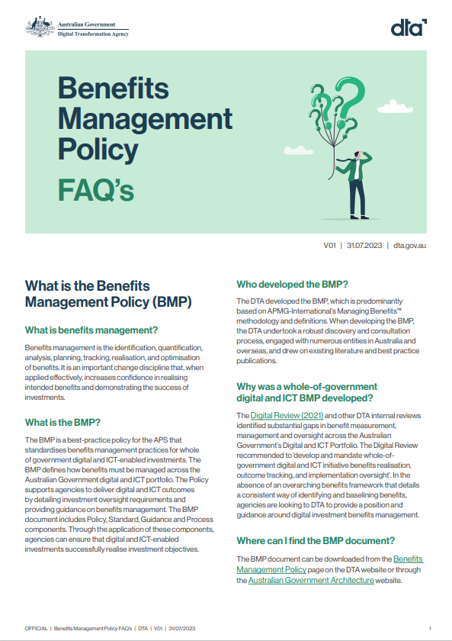**4. Frequently  
Asked  
Questions**

The DTA’s website provides a list   
of [Frequently Asked Questions](https://www.dta.gov.au/sites/default/files/2023-08/BMP%20FAQs%20DTA%20V01%2031072023.pdf)   
about the benefits management policy.

**Appendix**

## **Examples of Benefit Maps**

### Investment Logic Maps

This type of map, or an adaptation, is suitable for early-stage investments where digital and ICT-enabled solutions are yet to be identified and high-level project outputs are yet to be determined.

**

**Example 2[3]**

While not specifically ICT-related, this map is a good example of early problem identification and recognition of the enabling business changes required to achieve a specific benefit. This map is also suitable for early-stage investments where ICT solutions are yet to be identified.

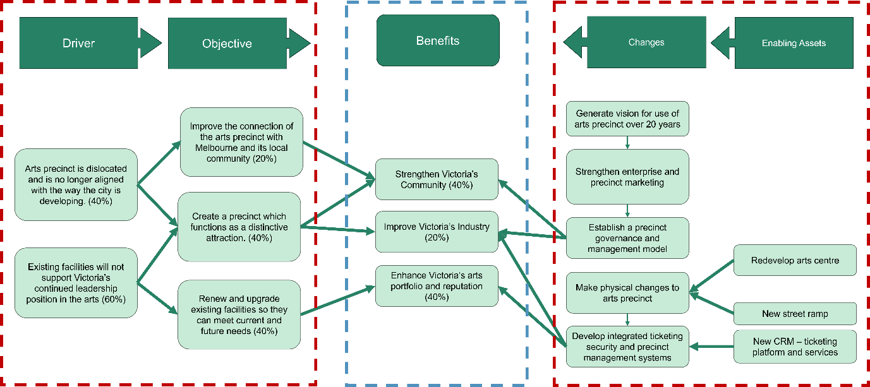

**Example 3[4]**

The benefits logic map (Jenner 2014) is beneficial to use where programs or projects are likely to realise interim benefits. This is useful for multi-stage programs as it can be used to demonstrate that programs of work remain on track to realise end benefits.

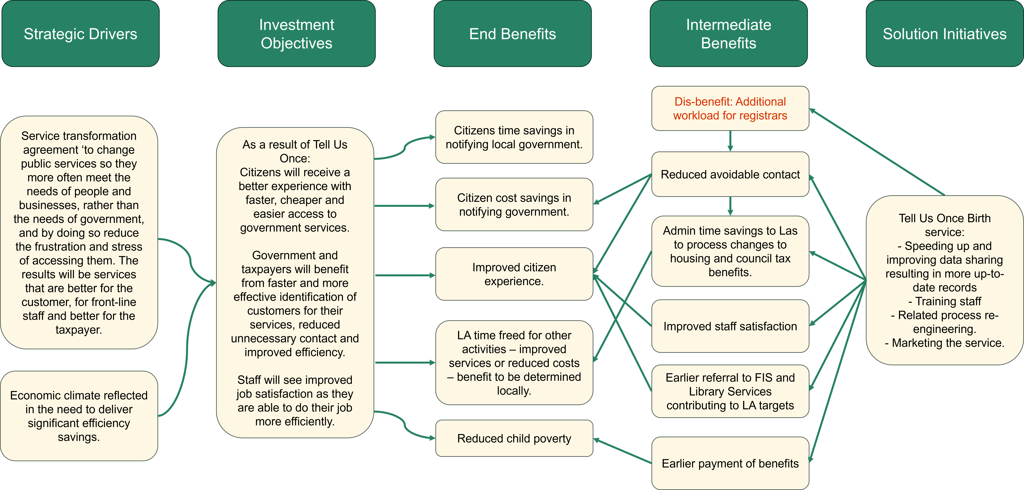

### Managing Successful Programmes (MSP) Map

The MSP Map is more suited to later stage investments where project teams have been onboarded and project outputs have been identified. Outputs can be linked to capabilities, outcomes and benefits which are, in turn, linked to strategic objectives.

‘Output, ‘Outcome’, ‘Capability’ and ‘Objective’ have specific meanings in the MSP context and users should familiarise themselves with these meanings prior to using this mapping technique.

NOTE: DCAP criterion 8.1 requires the benefits map to show the relationship between project outputs (where applicable), investment objectives, benefits and the business changes upon which they rely. Depending on investment size and complexity, it may be easier to modify the MSP map to incorporate elements of investment logic mapping (above) or benefits dependency mapping (below) to address this criterion more successfully.

**Example 4[5]**

### Benefits Dependency Map

The benefits dependency map is also suitable for later stage investments where high-level ICT solutions (IS/IT enablers) have been identified.

Enabling changes (people, process, technology) are usually one-off changes needed to achieve the stipulated business change which are, in turn, required to realise the benefits.

**Example 5[6]**

1. Jenner, S, 2014, *Managing Benefits – Optimizing the return from investments*, APMG International, 2nd edition.
2. Ideas Advisory (2007) [Investment Management Standard](https://ideasadvisory.com.au/wp-content/uploads/2020/04/IMS_2-01_Guideline_Standard_v2.01.pdf), accessed 10 December 2023.
3. Jenner S (2014) *Managing Benefits*, 2nd edn, TSO, Norwich.
4.
5. Adapted from Amplify (2021), [*MSP Technique*](https://www.amplify-now.com/blog/benefit-mapping-a-guide-to-achieving-your-business-goals), accessed 10 December 2023
6. ScienceDirect (2007) [*Justifying CRM projects in a business-to-business context*](https://www.sciencedirect.com/science/article/abs/pii/S0019850106001088), accessed 13 December 2023.